Press release Sulz am Neckar, Germany, October 2014

Safe and comfortable fixating

KIPP toggle clamp now available in stainless steel

Toggle clamps provide reliable fixation of construction and assembly parts. They offer sustainable, stable connections with minimum effort particularly in the tool and machine construction industry. The proven toggle clamps are now also available in stainless steel.
The KIPP toggle clamp has a unique, internal locking system that delivers added safety. It engages with an audible click and can only be released by pulling on the grip. Besides the high safety factor, the toggle clamp also scores with its long service life. Thanks to maintenance-free and high-quality joint bushings, it can easily withstand more than 300,000 clamping cycles.
Another highlight is the particularly ergonomic and user-friendly grip element made from polyamide that is designed to eliminate pressure points developing on the hand. The increased clearance between clamp arm and grip increases the ease of use and prevents pinching. Even when wearing safety gloves, the clamp can still be opened and closed easily, comfortably and safely.
KIPP toggle clamps can be attached and detached quickly and allow complete exposure and unobstructed removal of the workpiece. Their function is based on the toggle action principle. The toggle clamps have until now been available in steel with a nitrox protective finish. HEINRICH KIPP WERK now supplies all toggle clamp models and extensive accessories such as clamping spindles in stainless steel.

Characters with space:
Headline: 29 characters
Pre-head: 50 characters
Text: 1,419 characters
Total: 1,498 characters

HEINRICH KIPP WERK KG
Stefanie Beck, Marketing
Heubergstrasse 2
72172 Sulz am Neckar, Germany

Telephone: +49(0)7454 793-30
e-mail: s.beck@kipp.com

Additional information and press photos
See www.kipp.com, Region: Germany, Category: News/Newsroom

Photos

Image text:
The proven toggle clamp is now also available in a comfortable and user-friendly stainless steel design. Photo: KIPP

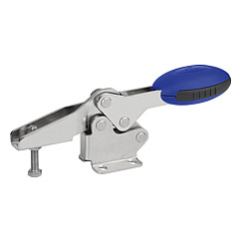
Image file:
KIPP_toggle clamp_horizontal_K0660.jpg

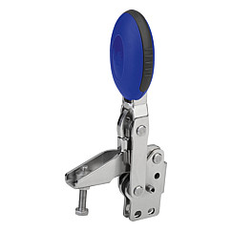
Image file:
KIPP_toggle clamp_vertical_K0663.jpg

Image copyright: Released for licence and royalty-free publication in speciality media.
With the request to cite the source and receipt.

