Press release Sulz am Neckar, Germany, May 2014

For the highest standards

KIPP presents new Premium Locking Bolts

With the high quality Premium Locking Bolts HEINRICH KIPP WERK presents a product extension that sustainably optimizes the portfolio for precision applications. The Premium Locking Bolts are characterized by accurate movement in the guide and a secure engagement in the end position.

Locking bolts are used where any change in locking position due to transverse forces should be prevented. The pin can be moved to a new index position only through manual application. In addition to easy handling, reliability, durability and quality play a particularly vital role - properties that have always been top priority at KIPP.

The KIPP program offers premium locking bolts in conical and cylindrical design that are available in both steel and stainless steel. All bolts have a mushroom knob made ​​of black-grey thermoplastic. They are used e.g. in pivoting or rotating fixtures as well as for end stop positioning.

A particular innovation in the product group - Premium Locking Bolts - is the design for thin-walled parts. Due to its very thin nut this version is suitable for mounting on components with thin walls. The KIPP Premium Locking Bolts can be fastened in any appropriate position and can also be used on sheet metal constructions.

Character with space:
Headline: 39 characters
Pre-head: 25 characters
Text: 1.235 characters
Total: 1.299 characters

HEINRICH KIPP WERK KG
Stefanie Beck, Marketing
Heubergstrasse 2
72172 Sulz am Neckar, Germany

Telephone: +49(0)7454 793-30
e-mail: s.beck@kipp.com

Additional information and press photos
See www.kipp.com, Region: Germany, Category: News/Newsroom

Photos

Image text:  These KIPP locking bolts are especially suitable for mounting on thin-walled parts  component. Photo: KIPP | 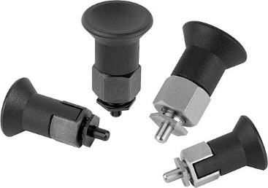  Image file:  KIPP_locking_bolts_thin_walled.jpg

Image text:  Premium locking bolts are characterized by more stringent manufacturing requirements for locking bolts and threaded sleeves. Photo: KIPP  Image copyright: Released for licence and royalty-free publication in speciality media. With the request to cite the source and receipt. | Image file:  KIPP_locking_bolts_cylindrical.jpg

